**My Current Collection Of Books:**

1). Book title and author

2). Genre

3). Image of each book

4). Book tile and short description

5). List each category separately (Title - Author - Genre - description- image)

6). Be able to sort Author and or title category separately and alphabetically. (ex. Authors by last name, Titles alphabetically).

7). Link to full library on nook: (<https://nook.barnesandnoble.com/my_library/ebook?sort=author_asc>)

8). Need a for loop to continuously add books.

9). Need a counter variable for all categories.

10.) Create a web server then add a post method handler to accept json payloads with the end goal of saving the data to a data base.

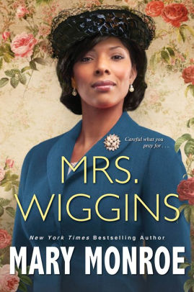 <https://prodimage.images-bn.com/pimages/9781496732583_p0_v1_s550x406.jpg>

## Mrs. Wiggins by Mary Monroe – *Overview: New York Times* bestselling author Mary Monroe returns to the Deep South Depression-era town of her scandalous Mama Ruby series, in this tale of a woman determined to have a respectable life—and she'll do anything to keep it... The daughter of a prostitute mother and an alcoholic father, Maggie Franklin knew her only way out was to marry someone upstanding and church-going. Someone like Hubert Wiggins, the most eligible man in Lexington, Alabama—and the son of its most revered preacher. Proper and prosperous, Hubert is glad to finally have a wife, even one with Maggie's background. For Hubert has a secret he desperately needs to stay hidden. And Maggie's unexpected charm, elegance, and religious devotion makes her the perfect partner in lies... Their surprising union makes the Wigginses the town's most envied couple—complete with a son, Claude, whom Maggie idolizes. Until he falls in love with the worst possible fiancée. Terrified, Maggie won't let this woman destroy her son. And when her employer's brother sexually harasses her, Maggie knows something needs to be done about him as well. In fact, she realizes there are an awful lot of "disruptive" people who should be eliminated from her perfect world... But the more Maggie tries to take control, the more obstacles are thrown in her way. And when it seems like the one person she always expected to be there is starting to drift away, Maggie will play one final, merciless game to secure what she's fought so hard to earn...

## Genre: Fiction/Contemporary Literature

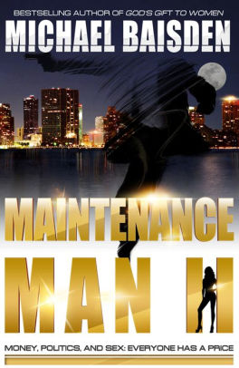<https://prodimage.images-bn.com/pimages/2940014408554_p0_v2_s550x406.jpg>

## MAINTENANCE MAN II by [MICHAEL BAISDEN](https://www.barnesandnoble.com/s/%22MICHAEL%20BAISDEN%22?Ntk=P_key_Contributor_List&Ns=P_Sales_Rank&Ntx=mode+matchall) – Overview MAINTENANCE MAN II: MONEY, POLITICS & SEX...EVERYONE HAS A PRICE.With "Maintenance Man II," Baisden broadens the storyline as Tremell comes out of retirement to not only rebuild his contact list of high-end female clientele, but also franchise a male escort service worldwide. Intrigue, drama and danger quickly come into play when Tremell liaisons with the wife of a powerful and corrupt Republican senator. When they unwittingly uncover the senator's underhanded deal with the powerful Kross brothers for political control, Tremell will have to tap his military training and street smarts to not only save his life, but also those closest to him. But with high rewards come high risks. Malcolm's world is turned upside down when he begins a relationship with Alex Nelson, the wife of a powerful and corrupt U.S. Senator. When Alex and Malcolm are suspected of knowing too much about an unscrupulous billion-dollar deal they suddenly becomes targets. He will need all of his military training and street smarts to get his life back and to get revenge!

Genre: Literature & Fiction

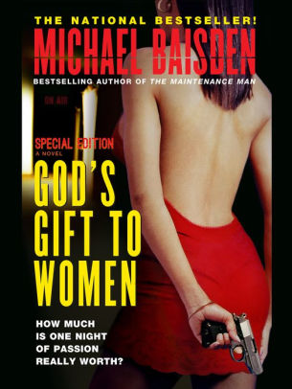 <https://prodimage.images-bn.com/pimages/2940151264228_p0_v1_s550x406.jpg>

## God's Gift To Women - Special Edition by [MICHAEL BAISDEN](https://www.barnesandnoble.com/s/%22MICHAEL%20BAISDEN%22?Ntk=P_key_Contributor_List&Ns=P_Sales_Rank&Ntx=mode+matchall) – *Overview* God's Gift To Women - Special Edition "How Much Is One Night Of Passion Really Worth?" A widower and father to ten-year-old Samantha, Julian wants nothing more than to settle down again with the right woman. Just when he thinks he's found her in Dr. Terri Ross -- smart, stunning, and with her own counseling practice -- Julian is confronted by a ghost from the past: Olivia Brown, a woman with whom he had a one-night stand. Suddenly Julian finds himself in a situation with a woman who's determined to win him over...or make his life a living hell. A national bestseller this suspenseful thriller about the perilous consequences of sex with an alluring stranger is Baisden's hottest book ever. Special Edition with new extended chapters!

Genre: Literature & Fiction

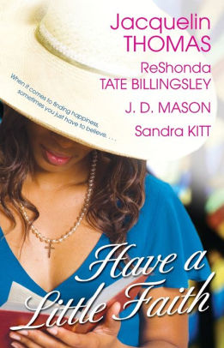 <https://prodimage.images-bn.com/pimages/9781416516767_p0_v4_s550x406.jpg>

# **Have a Little Faith** by [ReShonda Tate Billingsley](https://www.barnesandnoble.com/b/contributor/reshonda-tate-billingsley/_/N-2kjv), [Jacquelin Thomas](https://www.barnesandnoble.com/s/%22Jacquelin%20Thomas%22?Ntk=P_key_Contributor_List&Ns=P_Sales_Rank&Ntx=mode+matchall), [J.D. Mason](https://www.barnesandnoble.com/s/%22J.D.%20Mason%22?Ntk=P_key_Contributor_List&Ns=P_Sales_Rank&Ntx=mode+matchall), [Sandra Kitt](https://www.barnesandnoble.com/s/%22Sandra%20Kitt%22?Ntk=P_key_Contributor_List&Ns=P_Sales_Rank&Ntx=mode+matchall) - **Faith, family, and forgiveness are at the heart of this powerful story collection from four bestselling African-American authors. Meet a group of unforgettable women in these tales of hope and inspiration and discover how doors can open if you just have a little faith...** **JACQUELIN THOMAS - *Signs of Light:*** Businesswoman Lorna Hamilton has always looked down on unemployed single mothers, but she learns a valuable lesson when she befriends devout single mom Brittany Spencer and finds the family she’s been praying for. **RESHONDA TATE BILLINGSLEY - *Faith Will Overcome:*** Determined to leave her small town and broken family behind, Faith Logan believes finding a man is the solution to all her problems. But a chance meeting with Darius Williams helps her realize that all she needs is faith to find true happiness. **J. D. MASON *Maybelline***: Olivia Phillips’s world is falling apart, and the last thing she needs is her elderly neighbor knocking on her door. But kindly Maybelline won’t take no for an answer, and an uplifting friendship takes hold thanks to a little persistence and some homemade pie. **SANDRA KITT - *Survival Instincts:*** Even after an attempted mugging, librarian Lynn Hayes is devoted to her work in the bad part of town. Her rescuer, reporter Davis Manning, isn’t so forgiving, and it’s up to Lynn to show him that it is possible to save a community, one person at a time.

Genre: Christian Fiction

Authors:

# MICHAEL BAISDEN

1. Sawyer Bennett
2. ReShonda Tate Billingsley
3. Wanda B. Campbell
4. Diane Capri
5. Georgia Cates
6. Lee Child
7. Henry Cloud
8. Suzanne Collins
9. Michael Connelly
10. Adam Croft
11. Kyra Davis
12. Jeffery Deaver
13. Chiquita Dennie
14. Julia Derek
15. Eric Jerome Dickey
16. Eileen Dreyer
17. K.C. Falls
18. Amanda Feyerbend
19. Alex Grayson
20. Layla Hagen
21. D.F. Hart
22. Susan Hatler
23. Elin Hilderbrand
24. Stephen Hunter
25. E L James
26. E. N. Joy
27. Claire Kent
28. Nolon King
29. Sarah Langan
30. Shari Lapena
31. Piper Lawson
32. Alan Lee
33. Lutishia Lovely
34. Cyndee Rae Lutz
35. Nancy Mehl
36. Robin Merrill
37. Ronin Merrill
38. Rick Mofina
39. Mary Monroe
40. Victoria Christopher Murray
41. Steph Nuss
42. Joy Ohagwu
43. Joel Osteen
44. Ali Parker
45. James Patterson
46. Blake Pierce
47. Piper Rayne
48. Pamela D. Rice
49. Kimberla Lawson Roby
50. Elise Sax
51. Laura Scott
52. Jacquelin Thomas
53. Thomas Nelson
54. B P Walter
55. Skye Warren
56. Tiffany L. Warren
57. Carl Weber
58. Zane

**IDEAS FOR PROGRAM UPDATES:**

1. Possibly have the program start by asking for the user’s name and then have it say “Hello name. Welcome to my library!” Would you like to add a book, review a books description, or read a book?